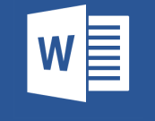

This document has been created in previous
Microsoft Office version.

In order to display this document correctly, it must be opened in Microsoft Office Word application, and then:
- ENABLE EDITING BUTTON HAS TO BE CLICKED.
- ENABLE CONTENT BUTTON HAS TO BE CLICKED.

Those two buttons will make the Microsoft Office Word convert this document to the new version.

